**SUMMER INTERNSHIP 2018**

**TITLE :** BILLING SOFTWARE FOR DIFFERENTLY- ABLED

**DATE :** 07.05.18 - 09.06.18

**DEPARTMENT :** DEPARTMENT OF INFORMATION

SCIENCE AND TECHNOLOGY

**PLACE :** COLLEGE OF ENGINEERING GUINDY

**CO-ORDINATOR :** DR.S.BAMA

**TEAM MEMBERS :** S.ASHWIN (2016115010)

B.K.ASHWINI (2016115011)

D.DHARANESHWAR (2016115015)

**INTRODUCTION:**

We are developing software for the use of differently-abled.  Differently-abled individuals are deterred from using computers due to their inability to use a hand-controlled mouse However, there are some alternative methods, such as ‘The Hawking communicator’ which was developed for Prof. Stephen Hawking. Using this setup, the individual can type messages and communicate using a simple ON/OFF switch. However, it does not cater to the needs of the Indian environment. and keyboard.

In India, an NGO named [**Vidyasagar**](http://www.vidyasagar.co.in/en/) is providing services focusing on early intervention, special education, speech and communication therapy, etc., in the field of disability. To help communicate and learn through computers, a non-contact switch namely, ADITI is used, which helps the individual to pin-point the particular item in the computer screen.  Although using the switch the computer could be accessed, not many applications are available. The computational requirements also vary from person to person. For example, children with visual impairment require bright colors and bigger fonts in the display; some children require a longer time to activate the switch; and to effectively understand the academic concepts, there is a need to provide an Indian accent of voice, while highlighting an item. Based on these requirements, we have developed software applications that are customized for the Indian scenario. These applications are enabled by a left-mouse click, which forms the basis for activating the device such as ADITI.

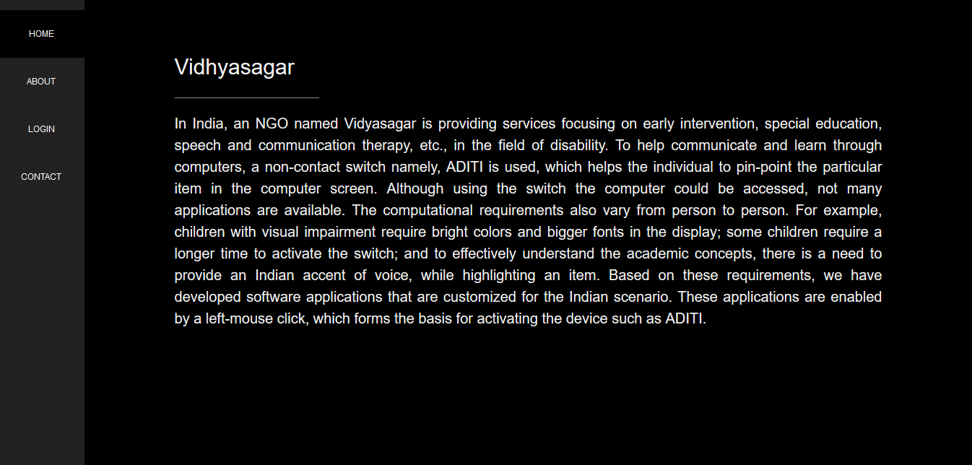

**ABOUT THE SOFTWARE:**

In **vidyasagar** , those differently- abled people are producing products like bags , purse etc. There is a need for a billing software to sell those products. our software aims at fulfilling their requirements. We have developed a web application which can be hosted on the internet.

**LANGUAGES USED:**

* HTML
* CSS
* JavaScript
* JQuery
* JSP and Servlets
* Shell Script
* Java

**PLATFORM**

* Windows Environment
* Apache-Tomcat server
* JDK environment

REFERENCES:

* Stackoverflow
* Geeksforgeeks
* Javatpoint
* Tutorialspoint
* W3schools

**WORKING:**

This Billing Software is used to produce bill with a single left-mouse click. It interfaces with ADITI device that is used to control the entire software. The admin page can be logged in with the admin username and password. The admin can upload the Product name, Product image, quantity and cost.

The user side they can choose their font size, cursor speed as their wish. They select the products with the help of the images. we used scanner mode throughout the software which help them to select the products while it traverse the row. There is a switch between one row to another row which helps them to select the required products with the help of the left mouse click. We can avoid the time consumption , unnecessarily traverse through the row which is not having the product the user required. only if we select the row then only it traverse through the row.

**USER LOGIN:**

Admin can logged in this page to upload the products.

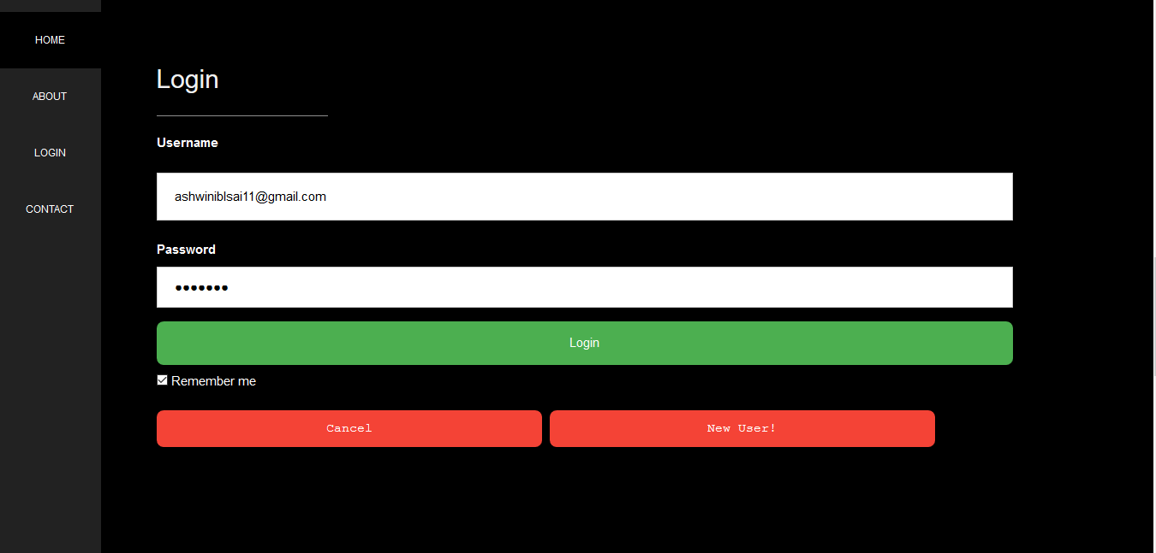

PRODUCT DETAILS :

This page will show the details of the product which is uploaded by the admin. He can add a new product ,edit or remove the existing products.

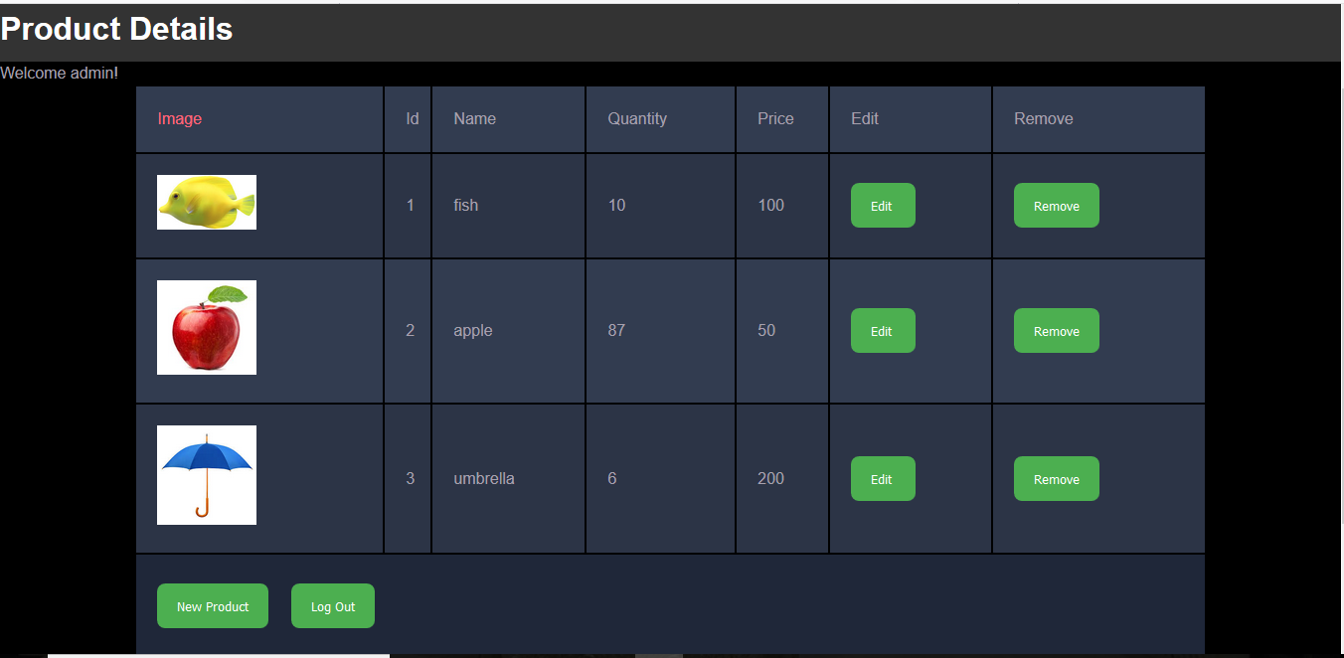

**ADD A NEW PRODUCT:**

In this page user can add a new product, upload it’s image and enter it’s quantity and price.

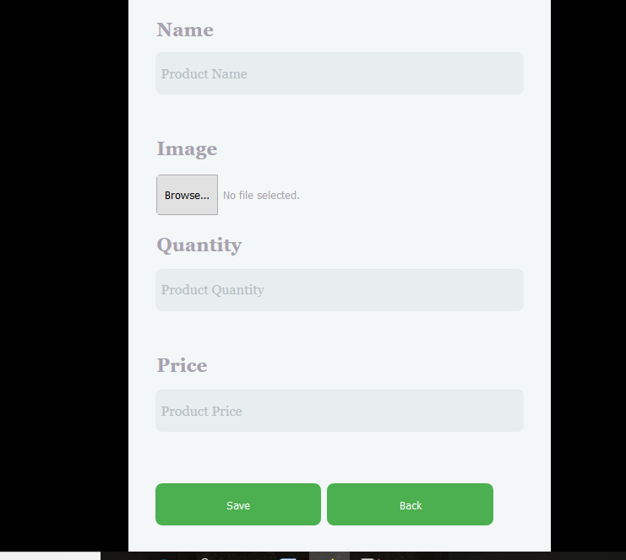

**START PAGE:**

This is the starting page of the billing software. It will go to the next page with a left mouse click wherever the cursor is. 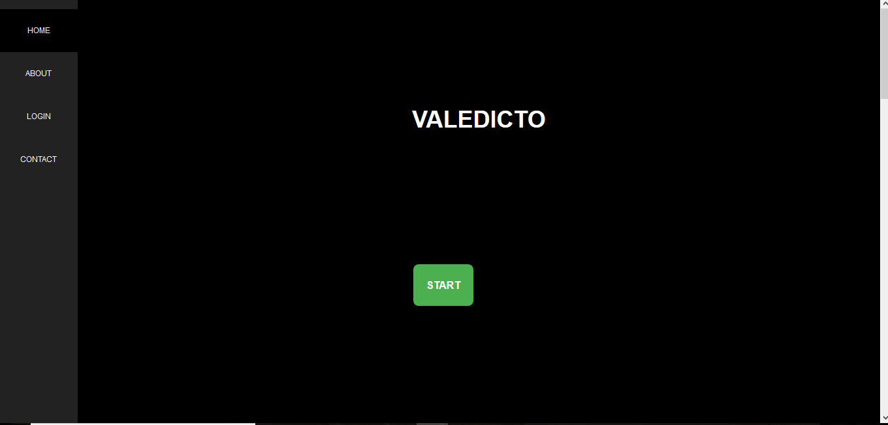

FONT SIZE:

This page is for selecting the font size throughout the software.

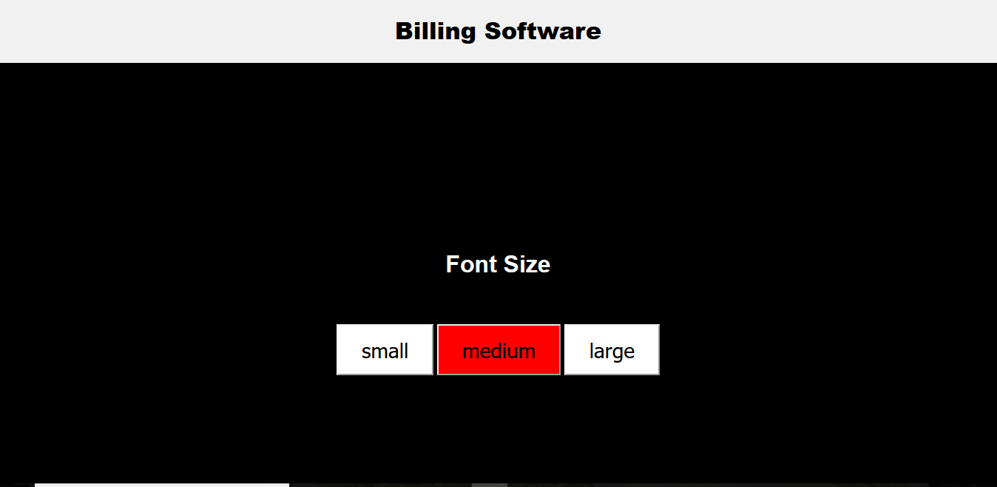

**CURSOR SPEED:**

This page is for selecting the cursor speed throughout the software.

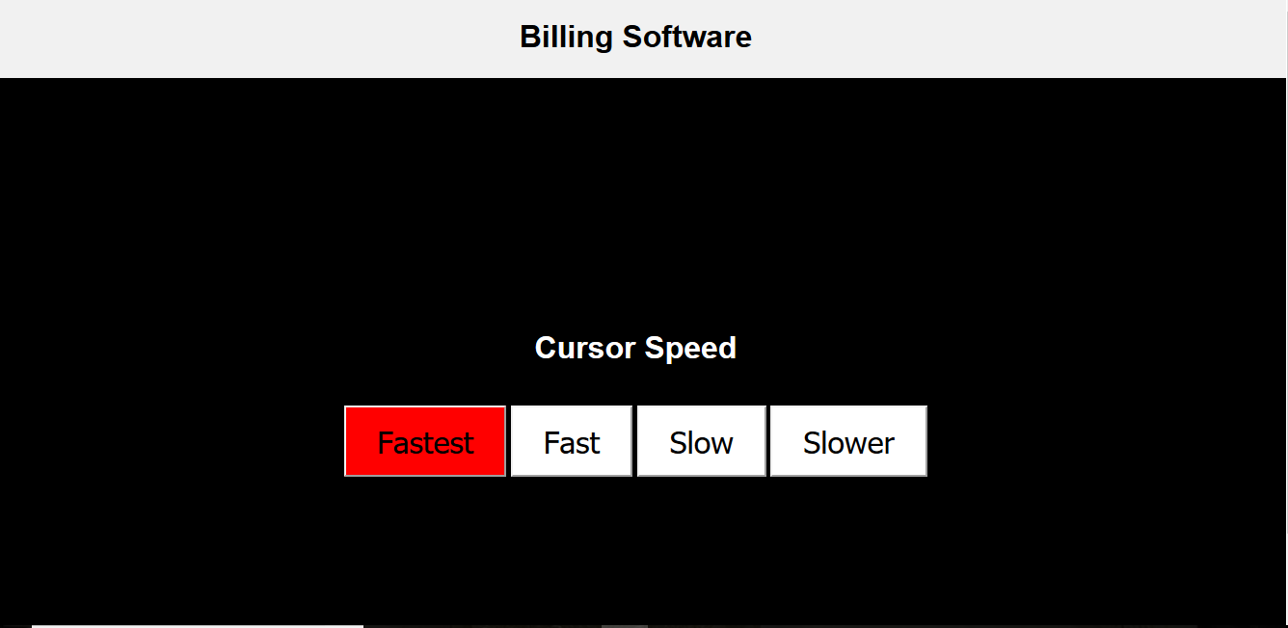

SELECT ITEMS:

This page displays the images of the available products. The user can select by looking at it’s image , available quantity and it’s price.

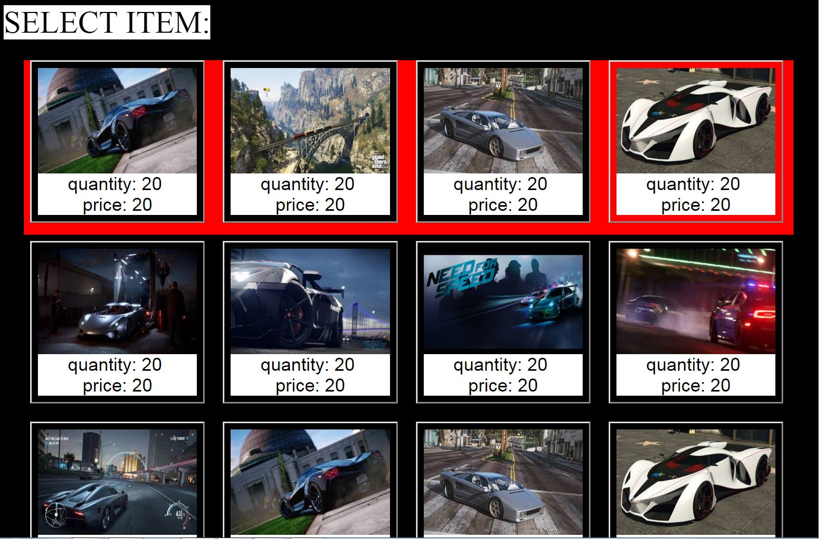

**SELECT QUANTITY:**

This page is used to select the quantity of the selected products.

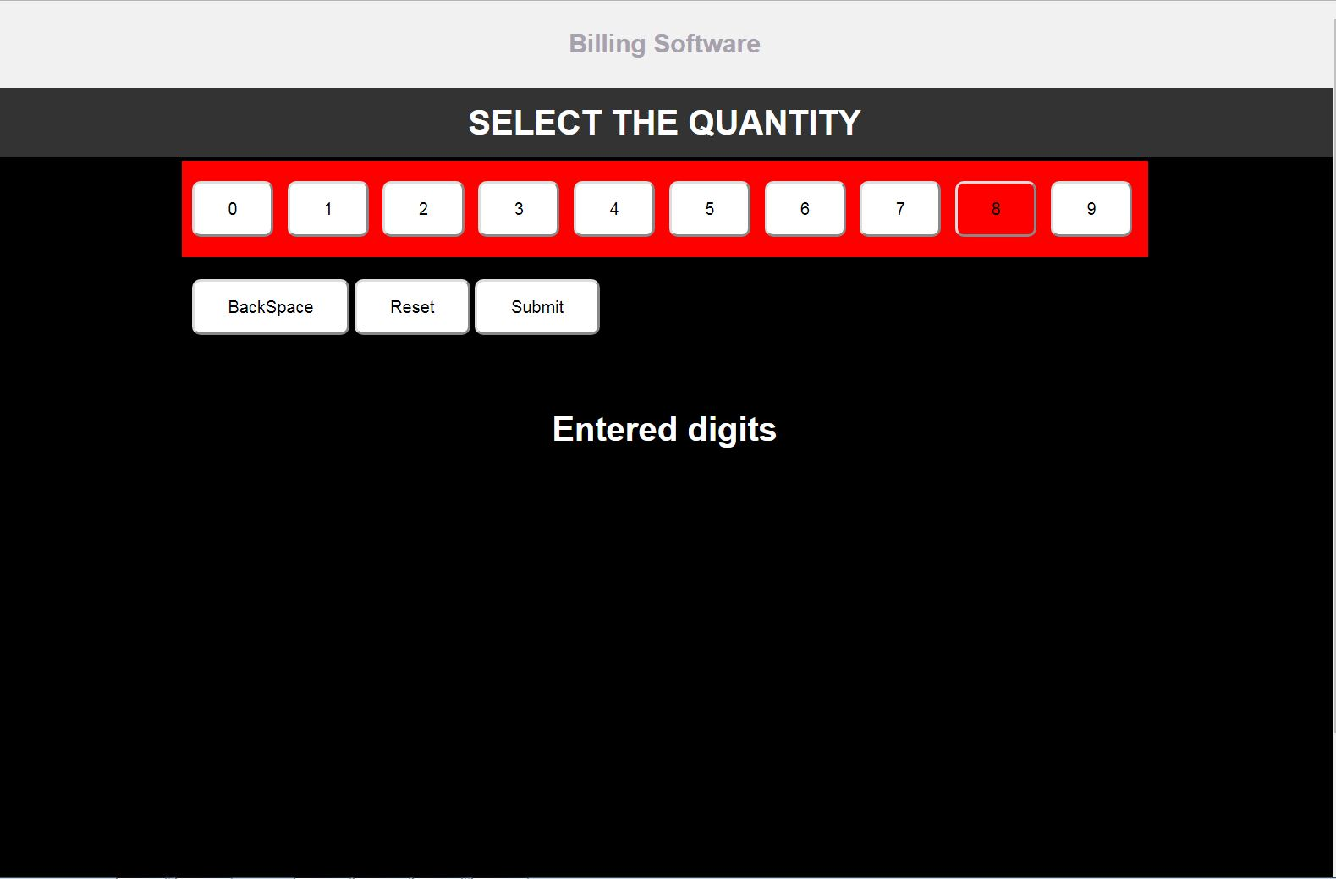

**ADD OR REMOVE SELECTED PRODUCTS**

The user can add a new product or remove the selected product.

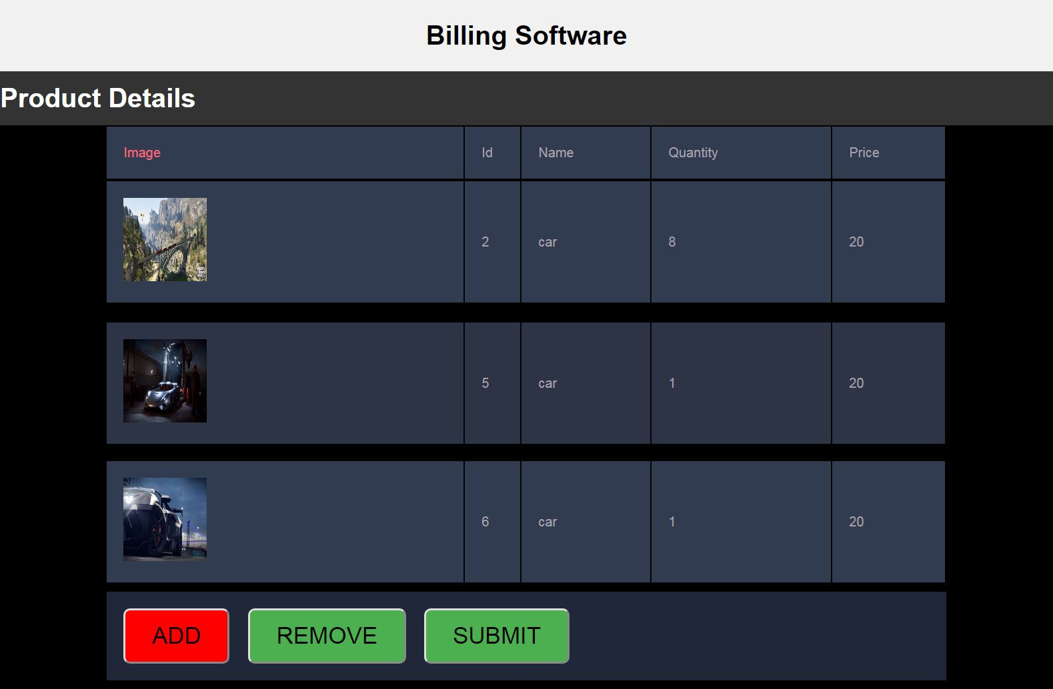

**REMOVE PRODUCT:**

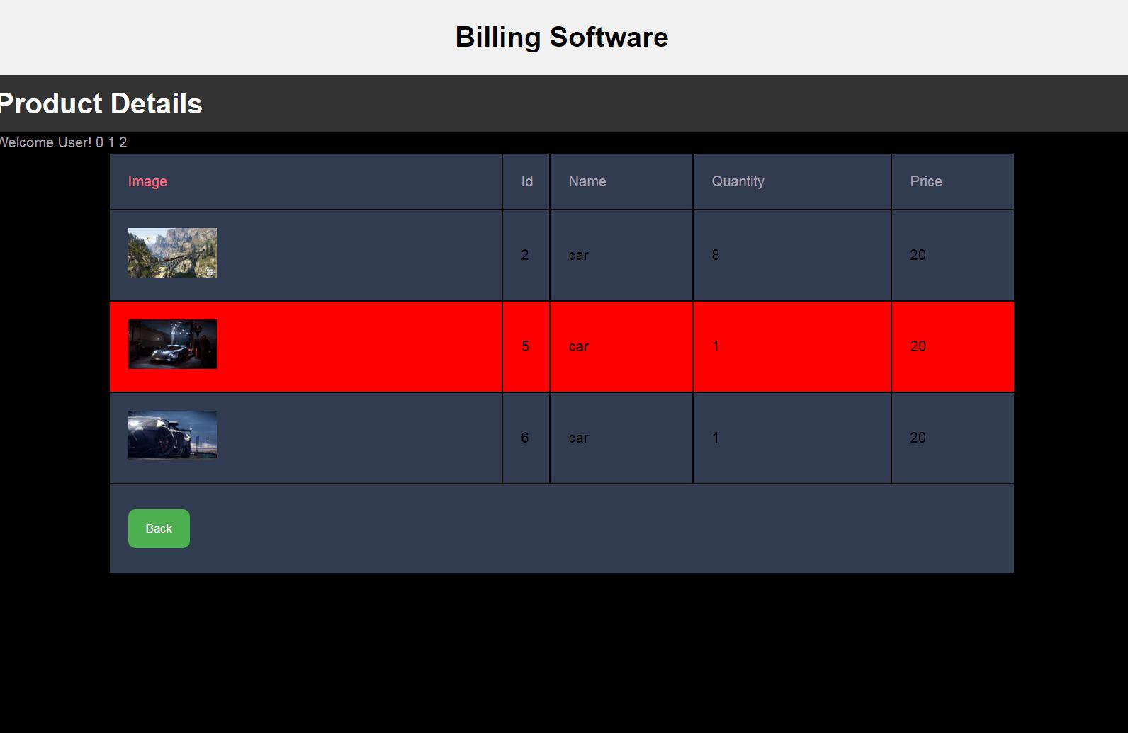

**BILLING :**

This page will give the bill of the purchased product.

